Digital Logic Design Final Project Report

:
Project Title: Single-Digit Up/Down Decade Counter with Master Reset


Submitted by:

Name | Registration No.
Muhammad Abdullah | FA24-BSE-042
Submitted to: Raheel Ahmed Course: Fundamental of DLD Dated: May 21, 2026.

DEPARTMENT OF COMPUTER SCIENCE COMSATS UNIVERSITY ISLAMABAD,
ISLAMABAD CAMPUS

- Project Overview
The objective of this project is to design and simulate a single-digit Up/Down Decade Counter using fundamental Digital Logic Design (DLD) principles. The circuit allows a user to manually increment (count up) or decrement (count down) a numeric value from 0 to 9, which is visually represented on a 7-segment display. Additionally, it features a Master Reset button to instantly return the counter to zero at any time.
This project demonstrates the practical application of sequential logic (counters), combinational logic (decoders), and proper digital circuit design techniques like switch debouncing/stabilization.
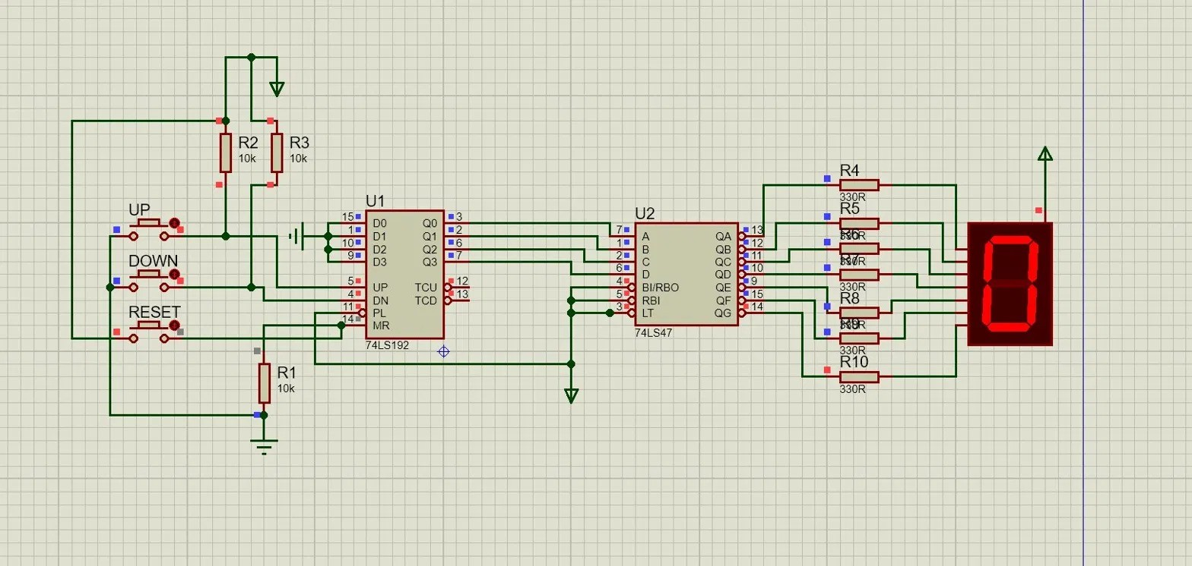

- Component Breakdown & Justification
Here is a detailed look at every component used in the circuit and exactly why it is necessary:

74LS192 IC (Up/Down Decade Counter)
    - What it is: This is the "brain" of the circuit. It is a synchronous decade counter, meaning it counts from 0 to 9 in binary (BCD format) and then rolls over.
    - Why it is used: Standard counters like the 74LS90 can only count upwards. The 74LS192 was chosen specifically because it has separate inputs for counting UP and DOWN, making it perfectly suited for a bidirectional project.

74LS47 IC (BCD to 7-Segment Decoder)
    - What it is: This acts as the "translator." The counter chips output numbers in 4-bit Binary Coded Decimal (BCD) (e.g., 0101 for the number 5). A 7-segment display cannot read binary. The 74LS47 reads that binary code and determines exactly which individual LED segments (a, b, c, d, e, f, g) need to turn on to shape the number '5' for human eyes.
    - Why it is used: It bridges the gap between machine language (binary) and
human-readable output (decimal numbers). It is specifically designed to work with Common Anode displays.

7-Segment Display (Common Anode)
    - What it is: The visual output screen made of 7 individual LEDs arranged in a figure-eight pattern. "Common Anode" means the positive sides of all 7 LEDs are tied together to VCC (5V).
    - Why it is used: To provide a clear, visual readout of the current count.

Push Buttons
    - What they are: Simple mechanical switches used for user input.
    - Why they are used: Three are required: one to send the "count up" signal, one for the "count down" signal, and one for the "reset" signal.

3kΩ Resistors (Pull-Up and Pull-Down)
    - What they are: High-value resistors connected to the button inputs.
    - Why they are used: Digital pins are highly sensitive. If a pin is not connected to anything (floating), it might pick up static electricity and randomly switch between HIGH (1) and LOW (0), causing the counter to glitch.
      - Pull-Up Resistors (R2, R3): Used on the UP and DOWN buttons to keep the signal stably at 5V (HIGH) until the button is pressed to pull it to Ground (LOW).
      - Pull-Down Resistor (R1): Used on the RESET pin to keep it stably at 0V (LOW) until the button is pressed to send 5V (HIGH).

330Ω Resistors (Current Limiters)
    - What they are: Lower-value resistors placed between the 74LS47 decoder and the 7-segment display.
    - Why they are used: To protect the hardware. Without these, too much current would flow from the 5V source straight through the LEDs, which would instantly burn out the
7-segment display.
- How the Circuit Works (Step-by-Step Logic)
The circuit operates in a continuous loop of reading user inputs, processing the math, and displaying the result.

The Default State:

When powered on, the pull-down resistor on the Master Reset (Pin 14) ensures the counter isn't stuck in a reset loop. The pull-up resistors on Pin 5 (UP) and Pin 4 (DOWN) keep the counter stable. The 74LS192 outputs 0000 in binary. The 74LS47 reads this, pulls the correct pins to ground, and the display lights up a "0".

Counting Up:

When the user presses the UP button, the voltage at Pin 5 drops from 5V to 0V. When the user lets go, it snaps back to 5V. The 74LS192 detects this change (the rising edge) and adds 1 to its internal memory. The binary output changes (e.g., to 0001), the decoder translates it, and the display updates to "1". If it reaches "9" and is pressed again, it rolls over back to "0".

Counting Down:

Similarly, pressing the DOWN button sends a pulse to Pin 4. The 74LS192 subtracts 1 from its internal memory. If the display shows "0" and the DOWN button is pressed, the chip underflows and loops backward to "9".

The Master Reset:

The Reset function overrides everything. When the RESET button is pressed, 5V is sent directly to the Master Reset pin (MR / Pin 14). The 74LS192 instantly erases its current count, forces its binary outputs back to 0000, and the display instantly shows "0", regardless of what the UP/DOWN buttons are doing.

Conclusion:

This circuit successfully integrates sequential counting logic with combinational decoding logic to create a reliable, user-controlled digital counter. The use of proper pull-up/pull-down networks ensures the logic gates operate without floating-pin errors, validating the core principles of Digital Logic Design.

